Nominal and ordinal encoding

1. **Nominal Encoding**

When we have a feature where variables are just names and there is **no order or rank** to this variable's feature.

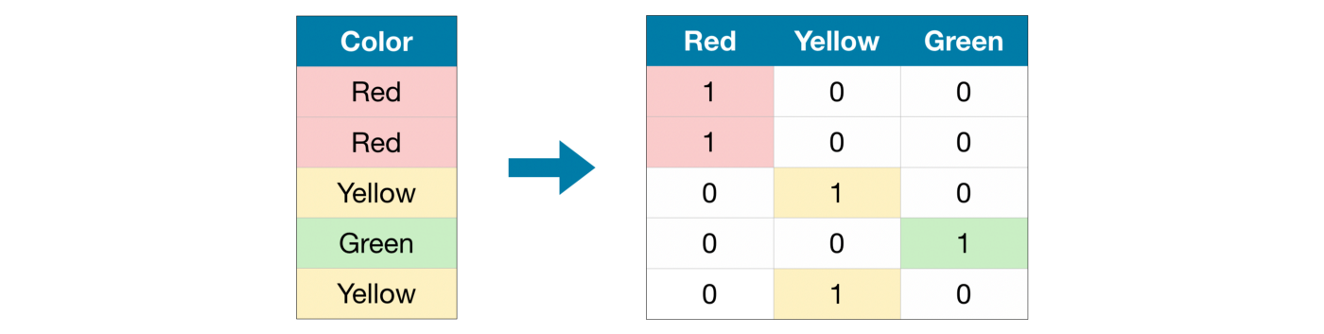

For example: City of person lives in, Gender of person, Marital Status, etc…

In the above example, We do not have any order or rank, or sequence. All the variables in the respective feature are equal. We can't give them any orders or ranks. Those features are called **Nominal features**.

2. **Ordinal Encoding**

When we have a feature where variables have some**order/rank**.

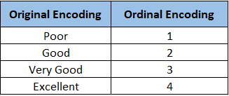

For example: Student’s performance, Customer’s review, Education of person, etc…

In the above example, we have orders/ranks/sequences. We can assign ranks based on student’s performance, based on feedback given by customers, based on the highest education of the person. Those features are called **Ordinal features**.

**Conclusion:**

Encoding is a required pre-processing step when working with categorical data.